CSD420 - Advanced Java Programming
GitHub Repository Setup Assignment

Name: Zachary White
Instructor: Darrell Payne
Date: 08/16/2026
Class: CSD420

GitHub Repository Link
https://github.com/DevZWhite/CSD420-306J-Advanced-Java-Programming-2267-DD

Screenshot of GitHub Repository
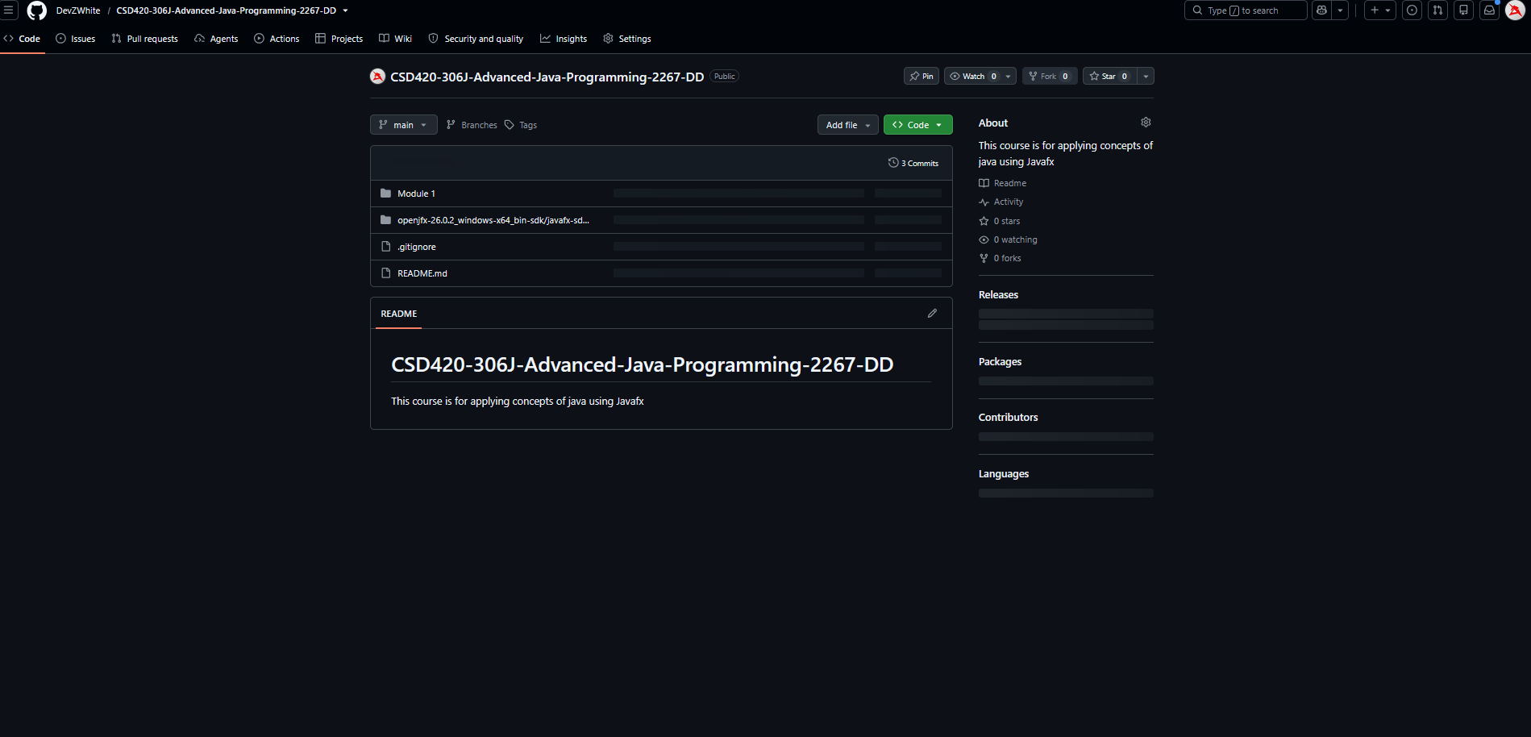

Screenshot of Local Directory
